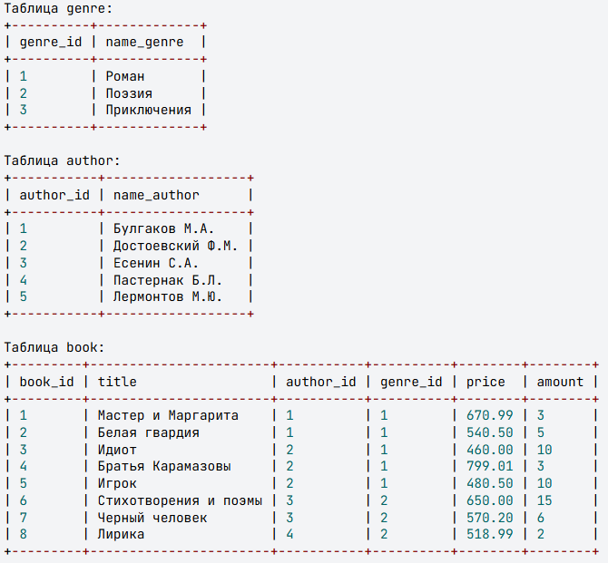
Inittial structure and data of tables

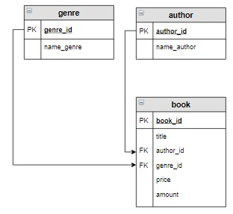
Database scheme

Task 1
Retrieve the title, genre, and price of books greater than 8, sorted in descending price order.

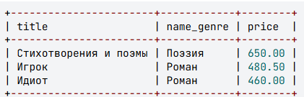

Task 2
Retrieve all genres that are not represented in the books in stock.

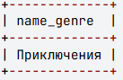

Task 3
There is a list of cities stored in the city table.
city_id | name_city
1 | Москва
2 | Санкт-Петербург
3 | Владивосток

A book exhibition by each author must be held in each city during 2020. The exhibition date must be randomly selected. Create a query that will return the city, author, and date of the exhibition. Name the last column "Date." Retrieve the information by sorting it first alphabetically by city name, and then in descending order by exhibition dates.

Table structure
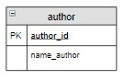
Date generation
(DATE_ADD('2020-01-01', INTERVAL FLOOR(RAND() * 365) DAY)) as Дата

Result:
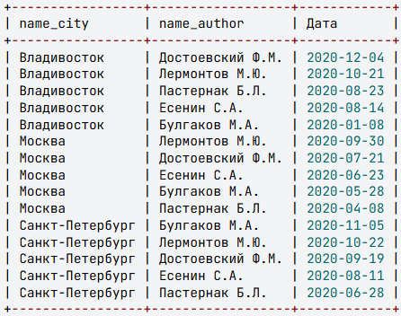

Task 4
Retrieve information about books (genre, book, author) that belong to a genre that includes the word "Роман" sorted by book title.
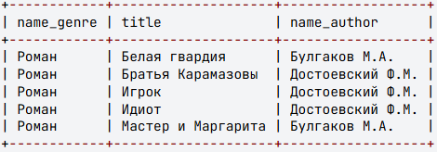

Task 5
Count the number of copies of books by each author from the author table. Display those authors whose number of books is less than 10, sorted by increasing quantity. Name the last column «Количество».
